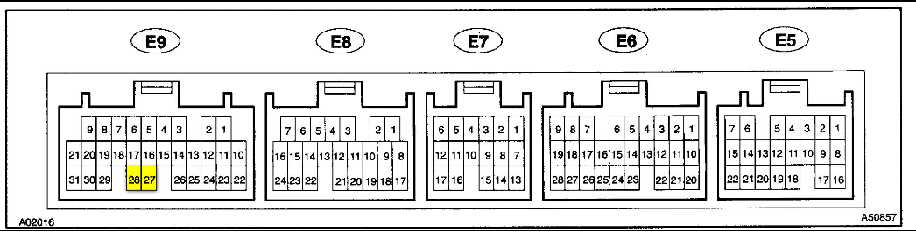
E5 (A) | Color | Symbol/Description | PIN | Color | Symbol/Description
1 | B-Y | BATT – EFI Fuse B | 12 | / | /
2 | B-R | IGSW – IGN Fuse A | 13 | / | /
3 | G-R | FC – Circuit Open Relay M | 14 | / | /
4 | / | / | 15 | G-W | STP – From Stop Light SW
5 | / | / | 16 | B-Y | +B – Ignition Power 12V – N
6 | G-R | W – Malfunction Lamp L | 17 | L-R | PTNK – Vapor Pressure Sensor
7 | GR | STA - From Park/Neutral Switch | 18 | B-Y | ELS2 – From “Mirror-Heater” Fuse
8 | B-W | MREL - Ignition Power 12V D | 19 | G-O | ELS – From “Tail” Fuse
9 | W-R | TPC – VSV (Vapor Pressure Sensor) | 20 | / | /
10 | / | / | 21 | / | /
11 | W | SIL – Data Link E | 22 | / | /
E6 (B) | Color | Symbol/Description | PIN | Color | Symbol/Description
1 | / | / | 15 | / | /
2 | R-B | R - Reverse- From Park/Neutral Switch | 16 | / | /
3 | L-W | 2 – Drive2- From Park/Neutral Switch | 17 | / | /
4 | L-R | IDLO – Cruise Control | 18 | / | /
5 | / | / | 19 | / | /
6 | / | / | 20 | B-W | NSW – From Starter Fuse
7 | / | / | 21 | / | /
8 | B | OXS – Heated Oxygen Sensor | 22 | V-W | SPD – To Speedometer
9 | P-B | HTS – Heated Oxygen Sensor | 23 | / | /
10 | G-O | OD2 – O/D Switch | 24 | Y-B | OD1 – Cruise Control
11 | / | / | 25 | B-Y | A/C – From AC Control Assembly
12 | Y | L – Low - From Park/Neutral Switch | 26 | / | /
13 | LG-B | ACT – To AC Control Assembly | 27 | B-O | TACH – To Tachometer
14 | V |  | 28 | / | /
E7 (C) | Color | Symbol/Description | PIN | Color | Symbol/Description
1 | / | / | 10 | L-Y | TXCT – Transponder Key Amplifier
2 | / | / | 11 | L-B | KSW – To Unlock Warning SW
3 | / | / | 12 | / | /
4 | G-W | CODE – Transponder Key Amplifier | 13 | BR | EOM – Data Link G
5 | R-L | RXCK – Transponder Key Amplifier | 14 | / | /
6 | / | / | 15 | / | /
7 | / | / | 16 | R-Y | IMLD – From Theft Deterrent ECU
8 | / | / | 17 | / | /
9 | / | /

E8 (D) | Color | Symbol/Description | PIN | Color | Symbol/Description
1 | / | / | 13 | G-Y | THG – EGR Gas Temp Sensor
2 | Y | VC – Powers VTA,PTNK,EGLS | 14 | G-B | THW – Engine Coolant Temp Sensor
3 | L-B | HTR – Heated Oxygen Sensor | 15 | / | /
4 | Y-R | HTL – Heated Oxygen Sensor | 16 | B-R | NE+ - Camshaft Position Sensor
5 | L | #10 Injector | 17 | BR | E1
6 | R | #20 Injector | 18 | BR | E2 – THG,THW,VTA1,PTNK,EGLS,THA GND
7 | LG | EVP1 – VSV(EVAP) | 19 | R-B | E2G - Mass Air Flow Meter
8 | / | / | 20 | / | /
9 | B-L | PS – Power Steering Oil Pressure SW | 21 | / | /
10 | P | VG - Mass Air Flow Meter | 22 | L-Y | THA - Mass Air Flow Meter
11 | W | OXR1 – Heated Oxygen Sensor | 23 | LL | VTA1 - Throttle Position Sensor
12 | B | OXL1 – Heated Oxygen Sensor | 24 | L | NE- - Camshaft Position Sensor
E9 (E) | Color | Symbol/Description | PIN | Color | Symbol/Description
1 | Y | #30 Injector | 17 | R-Y | ACIS – VSV(Intake Air Control)
2 | W | #40 Injector | 18 | Y-G | EGR – VSV(EGR)
3 | R-L | #50 Injector | 19 | B-Y | SLN- - Transmission
4 | G | #60 Injector | 20 | W-L | SLN+ - Transmission
5 | / | / | 21 | BR | E01 GND
6 | L-W | TC - Data Link F | 22 | W-G | EGLS – EGR Valve Position Sensor
7 | V | S1 – Transmission | 23 | BR | ADJ2 GND
8 | L-B | S2 – Transmission | 24 | / | /
9 | P-L | SL - Transmission | 25 | W-R | IGF - RPM Signal - Igniter
10 | B-W | G22+ -Camshaft Position Sensor | 26 | G | NC2- - Speed Sensor Transmission
11 | GR | IGT1 - Igniter 1 | 27 | GR | KNKR - Knock Sensor 1
12 | BR-Y | IGT2 - Igniter 2 | 28 | GR | KNKL – Knock Sensor 2
13 | LG-B | IGT3 - Igniter 3 | 29 | G-W | CF – From Fan No.1 Relay
14 | R | NC2+ Speed Sensor Transmission | 30 | BR | E03 GND
15 | Y-B | RSC – Idle Air Control Valve | 31 | BR | E02 GND
16 | R-W | RSO – Idle Air Control Valve

